Lot 78 and Pt Lot 79 DP 755907
Rose Street
Hyams Beach
Prepared for
Shoalhaven City Council
November 2022
COWMAN STODDART PTY LTD
DEMOLITION OF HYAMS BEACH
FORMER RURAL FIRE SERVICE FIRE STATION

REVIEW OF ENVIRONMENTAL FACTORS

REVIEW OF ENVIRONMENTAL FACTORS

Project | Demolition of Former Hyams Beach Rural Fire Service Fire Station
Address | Lot 78 and Pt Lot 79 DP 755907 Rose Street, Hyams Beach
Our ref: | 21/116
Prepared by | Stuart Dixon
© Cowman Stoddart Pty Ltd
This document is and shall remain the property of Cowman Stoddart Pty Ltd. The document may only be used for the purpose for which it was commissioned and in accordance with the General Terms & Conditions for the commission.
Unauthorised use of this document in any form whatsoever is prohibited.

CONTENTS

1.0 INTRODUCTION 1
1.1 Foreword 1
1.2 SITE CONTEXT AND SURROUNDS 1
1.3 SURROUNDING DEVELOPMENT 5
1.4 BRIEF SCOPE OF WORKS 5
2.0 description of PROPOSED works 6
2.1 JUSTIFICATION OF THE PROPOSAL 6
2.2 DEFINITION OF PROPOSED WORKS 6
2.3 SUMMARY OF WORKS 6
3.0 STATUTORY SITUATION 7
3.1 GENERAL PLANNING CONTEXT 7
3.2 State Legislation 8
3.3 State Policies 11
3.3.1 NSW Coastal Policy 11
3.3.2 SEPP (Transport and Infrastructure) 2021 11
3.3.3 SEPP (Resilience and Hazards) 2021 15
3.3.3.1 Chapter 2 – Coastal Management 15
3.3.3.2 Chapter 4 – Remediation of Land 18
3.3.4 State Environmental Planning Policy (Biodiversity and Conservation) 2021 19
3.4 Shoalhaven Local Environmental Plan 2014 (SLEP) 19
3.5 DRAFT PLANNING INSTRUMENTS 21
3.6 DEVELOPMENT CONTROL PLANS 21
4.0 ENVIRONMENTAL CONSIDERATIONS 22
4.1 TOPOGRAPHY AND SOILS 22
4.2 water and soil quality issues 22
4.2.1 Acid Sulfate Soils 22
4.2.2 Soil Erosion and Sedimentation Control 22
4.2.3 Site Contamination 23
4.3 FLORA AND FAUNA 23
4.4 VISUAL IMPACT 23
4.5 Heritage 24
4.5.1 Indigenous Heritage 24
4.5.2 Non-Indigenous Heritage 24
4.6 TRAFFIC and transportation IMPACTS 25
4.7 amenity IMPACTS 26
4.8 SERVICING 27
4.9 WASTE MANAGEMENT 27
4.10 natural hazards 28
4.10.1 Bushfire 28
4.10.2 Flooding 29
5.0 CONSIDERATION OF ENVIRONMENTAL IMPACTS 30
6.0 RECOMMENDATIONS FOR environmental management 34
6.1 Licences and Approval Requirements 34
6.2 recommendations for Environmental Management 34
7.0 CONSULTATION 38
8.0 CONCLUSION and RECOMMENDATIONS 39
9.0 DETERMINATION 40

FIGURES

Figure 1 Subject Site
Figure 2 Site Locality Plan
Figure 3 Aerial Photo of Site
Figure 4 Coastal Wetlands and Littoral Rainforests Area Map
Figure 5 Coastal Environment Area overlay
Figure 6 Coastal Use Area Map
Figure 7 Zoning Map (Shoalhaven LEP 2014)
Figure 8 Bushfire Prone Land (Shoalhaven City Council)

ANNEXURES

Annexure 1 Statement of Heritage Impact
prepared by Conservatory One
Annexure 2 Waste Management Plan prepared by
Environment and Natural Resources Solutions
Annexure 3 NSW Coastal Policy 1997 – Compliance Checklist
prepared by Cowman Stoddart Pty Ltd

Document Status
Draft | Issued for Client Comment | 28th July 2022
Final for public consultation | Issued | 3rd February 2023
Final | Issued

INTRODUCTION

1.1 Foreword
This Review of Environmental Factors (REF) has been prepared for Shoalhaven City Council and assesses the potential environmental impacts which could arise from the demolition of the former Hyams Beach NSW Rural Fire Service (RFS) fire station, which is identified by the Shoalhaven LEP 2014 as a local item of environmental heritage. The building has been constructed partly in asbestos material and was originally constructed for use and occupation by NSW RFS who relocated to a purpose built facility in 2012. It is now vacant due to numerous issues including the presence of hazardous materials and joint building ownership. The building is not fit for purpose.
The building has been constructed over two lots which now has two separate owners as a result of an Aboriginal Land Claim to Jerrinja Local Aboriginal Land Council.
This REF has been prepared in accordance with the relevant provisions of the Environmental Planning and Assessment Act 1979 (EP&A Act), the Environmental Planning and Assessment Regulation 2000 (the Regulation).
On the basis of the consideration of key environmental aspects and the information presented in this REF, it is concluded that by adopting the mitigation measures identified in this assessment, it is unlikely that there would be significant environmental impacts associated with the proposal.

1.2 SITE CONTEXT AND SURROUNDS
The subject site contains the former NSW Rural Fire Service fire station at Hyams Beach which is a single storey clad building that is currently unoccupied. This is shown in Plates 1 and 2 below.
The building is identified by the Shoalhaven LEP 2014 as an item of environmental heritage with local significance, identified as “Hyams Beach bushfire station” being item No. 214.
As shown in Figure 1 below, the subject site comprises:
- Pt Lot 78 DP 755907 owned by Crown Lands; and
- Lot 79 DP 755907 owned by the Jerrinja Local Aboriginal Land Council.
The property has frontage to Rose Street, Hyams Beach. Hyams Beach is a coastal village located on the shores of Jervis Bay, and is approximately 25 km south-east from Nowra, the major town servicing the Shoalhaven Council local government area. Figure 2 is a site locality plan, while Figure 3 is an aerial photo of the locality.
Rose Street is a sealed public road maintained by Shoalhaven Council.
Land in the vicinity of the subject site comprises bushland to the north, west and south, whilst single detached dwellings are located opposite Rose Street to the east.
The subject site is zoned SP2 Infrastructure pursuant to the Shoalhaven LEP 2014. ‘
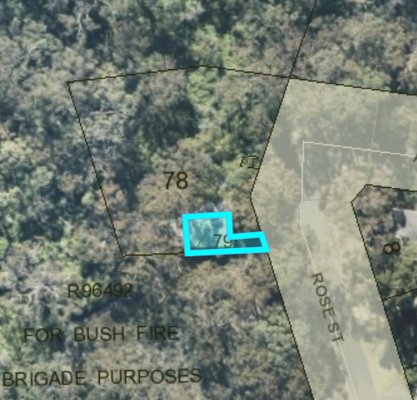
Figure 1 : Subject Site
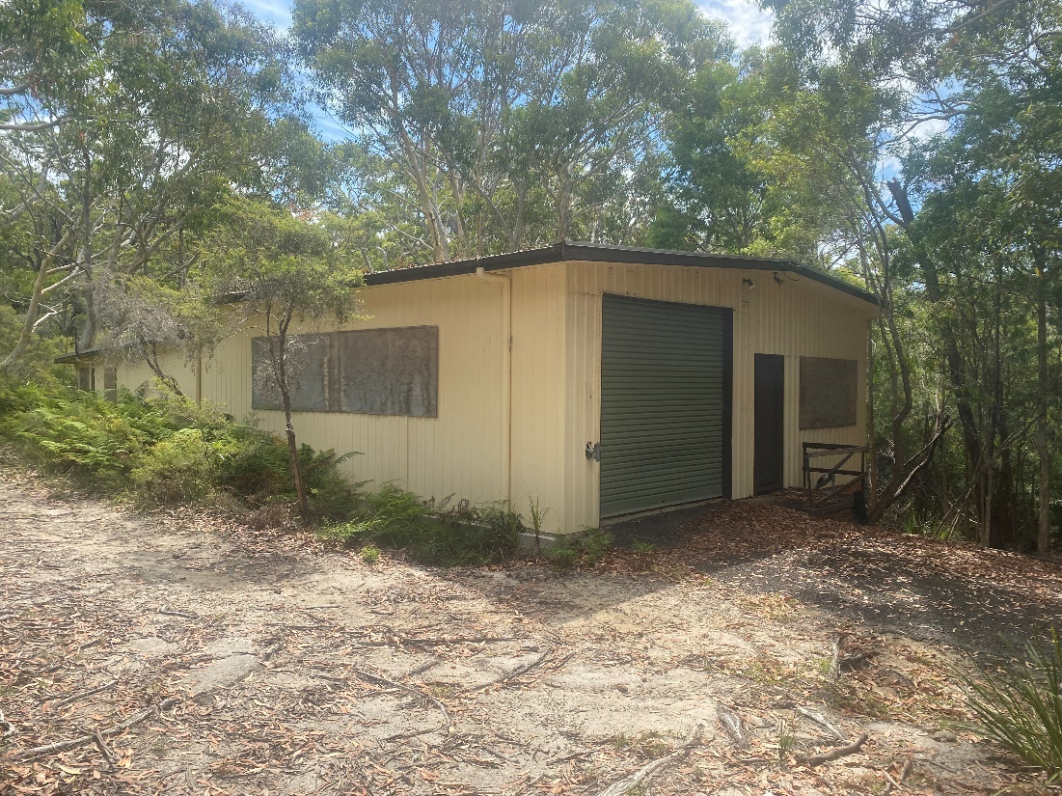
Plate 1: NSW Rural Fire Service fire station – Hyams Beach.

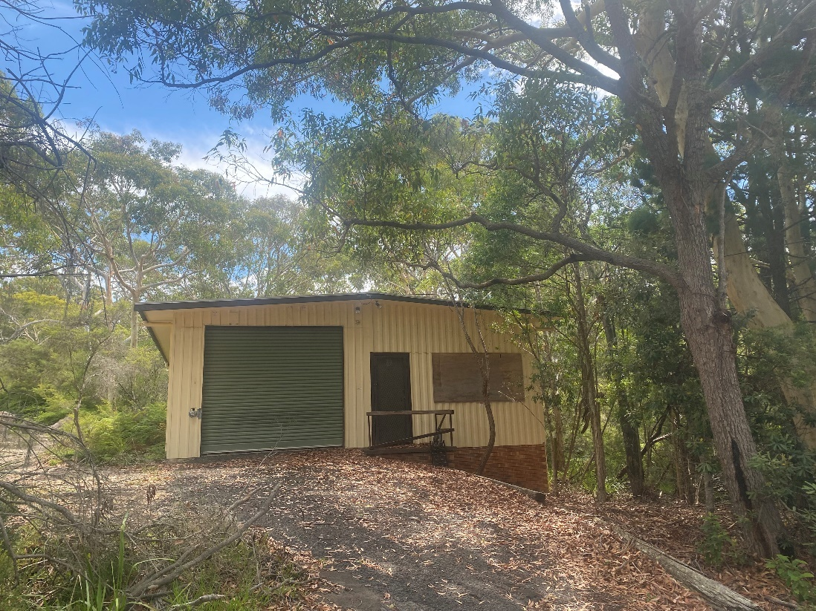
Plate 2: NSW Rural Fire Service fire station – Hyams Beach.

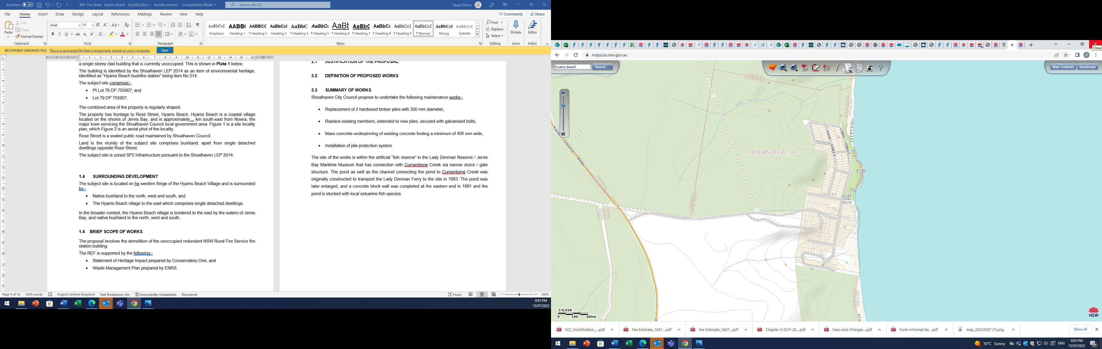
Site
Figure 2 : Site Locality Plan

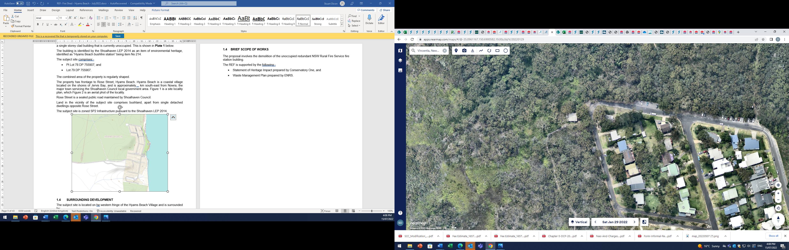
Site
Figure 3: Aerial photo of site.

1.3 SURROUNDING DEVELOPMENT
The subject site is located on the western fringe of the Hyams Beach Village and is surrounded by:
- Native bushland to the north, west and south; and
- The Hyams Beach village to the east which comprises single detached dwellings.
In the broader context, the Hyams Beach village is bordered to the east by the waters of Jervis Bay, and native bushland to the north, west and south.

1.4 BRIEF SCOPE OF WORKS
The proposal involves the demolition of the NSW Rural Fire Service fire station building.
The REF is supported by the following:
- Statement of Heritage Impact prepared by Conservatory One (CO); and
- Waste Management Plan prepared by Environment & Natural Resources Solutions (ENRS).

2.0 description of PROPOSED works

2.1 JUSTIFICATION OF THE PROPOSAL
The building the subject of this REF was used by the NSW Rural Fire Service as a Fire Station, however the brigade relocated elsewhere in approximately 2012 into an alternative facility.
The property was occupied by the local community group and subsequently vacated due to hazardous building materials used in its construction in the form of asbestos sheeting. The building continues to deteriorate and has become a health, safety and security issue for the community.
Council has reviewed opportunities for the reuse of the building, however due to the nature of the ownership and hazardous material issues, the most suitable solution is to demolish the structure. Further, the size of the land owned by Crown Lands which comprises an area of only 88.52 m² is not sufficient for the construction of any other building.

2.2 DEFINITION OF PROPOSED WORKS
The proposed works are demolition of the building in its entirety which will be subject to compliance with the relevant regulations in relation to the removal and disposal of hazardous material.

2.3 SUMMARY OF WORKS
Shoalhaven City Council propose to completely demolish the existing building and remove all material from the site.
The works are to be undertaken in accordance with the recommendations of the:
- Statement of Heritage Impact prepared by CO; and
- Waste Management Plan (WMP) prepared by ENRS.
The WMP prepared by ENRS has calculated the volume of waste that will be generated by the proposed demolition and identified the disposal method of the asbestos material.
No future use of the property has been identified at this time.

3.0 STATUTORY SITUATION
This section of the REF describes the statuary framework under which the proposal has been assessed.

3.1 GENERAL PLANNING CONTEXT
LEP Name | Shoalhaven LEP 2014
LEP Zoning | SP2 Infrastructure
Is the existing zone a prescribed zone for the purposes of Transport and Infrastructure SEPP > | Yes – the area of the works is demolition is permissible without consent within the SP2 zone pursuant to the provisions of SEPP Transport and Infrastructure 2021.
Permissibility | Development for the purposes of demolition is permissible without consent pursuant to the to the provisions of SEPP Transport and Infrastructure 2021.
Is the site environmentally sensitive land under any environmental planning instrument ? | No.
Does the site comprise bushfire prone land ? | Yes.
List any environmental constraints | Acid Sulfate Soil – Class 5  Sited within the Jervis Bay region where Clause 7.20 of the Shoalhaven LEP 2014 applies
Is the site listed as an item of environmental heritage or within a Heritage Conservation Area ? | Yes – the subject site is identified as an item of environmental heritage by the Shoalhaven LEP 2014.

With respect to the above, the following matters are relevant:
- The site is identified as potentially acid sulfate soils, being mapped Class 5. However, the subject site is not located within 500 m of other potential ASS, and nor are the works expected to lower the water table. Consequently, no implications arise,
- The site is within the area where Clause 7.20 of the Shoalhaven LEP 2014 applies. The proposal, being for the demolition of a NSW Rural Fire Service fire station does not offend any provisions of this clause. The proposal does not result in any adverse environmental impacts. Cultural impacts arising from the demolition of an identified heritage item are addressed below.
- The proposal involves the demolition of an item of environmental heritage. Accompanying this REF is a Statement of Heritage Impact prepared by CO (Annexure 1) which has assessed the significance of the building the subject of the works, and the impacts of the proposed works.

3.2 State Legislation
Environmental Planning & Assessment Act, 1979
Generally, the environmental assessment procedures for development fall within the provisions of the Environmental Planning & Assessment Act (EP&A Act), and in particular, Divisions 4 and 5 of this Act. If Division 4 consent is required (ie. a development application is required) then the assessment provisions as outlined under Part 4 apply. Where these procedures do not have to be followed because development consent is not required under the relevant environmental planning instrument, the environmental assessment provisions outlined within Division 5 of the Act are required to be complied with. Division 5 assessment is normally associated with public infrastructure undertakings, such as that which is proposed.
As is detailed in the body of this REF, the proposed activities are to be carried out within the City of Shoalhaven, pursuant to State Environmental Planning Policy (Transport and Infrastructure) where Section 2.52 enables the demolition of emergency facilities without consent.
The assessment of the environmental effects of the proposal is therefore being considered under Division 5 of the Environment Planning & Assessment Act, being a proposal which is permissible, does not require planning consent and an activity which is to be carried out by a public authority. On this basis, this report provides a Review of Environmental Factors for the proposed activity in accordance with Section 5.5 of the EP&A Act and Clause 228 of the Environmental Planning & Assessment Regulations. This is further discussed in detail in Section 3.3.2 of this REF.
Contaminated Land Management Act 1997
The Contaminated Land Management Act (CLM Act) is the relevant NSW State legislation dealing with the contamination of land. In essence, it provides the NSW Environment Protection Authority the power to amongst other things, declare land to be significantly contaminated, order management action, and obligate landowners and operators who carry on contaminating activities to notify the EPA of the contamination of land in certain circumstances.
The works proposed in this application involve the demolition of a NSW Rural Fire Serve fire station, which contains asbestos material. The asbestos material is to be removed in accordance with the relevant standards.
Matters arising from soil contamination are addressed in the Waste Management Plan prepared by ENRS (Annexure 2).
Subject to adherence to the recommendations of ENRS, no contamination issues arise.
Protection of the Environment Operations Act
The Protection of the Environment Operations Act (POEO Act) commenced on 1 July, 1999. This legislation provides a single licensing arrangement to replace the different licences and approvals under previous pollution control legislation (ie. Clean Air, Water and Noise and Waste Management).
The EPA is the regulatory authority for activities specified in Schedule 1 of the Act (scheduled activities). Local Government is the regulatory authority for non-scheduled activities, except activities undertaken by a public authority which the EPA will regulate. The EPA licenses scheduled activities. Schedule 1 of the POEO Act has been reviewed and the proposal does not trigger any of the activities.
Compliance with the POEO (Waste) Regulations will be required having regard to the disposal of asbestos material.
Biodiversity Conservation Act
The Biodiversity Conservation Act establishes a framework and scientific method for measuring the impact of proposed developments on biodiversity values and subsequent tools to avoid, minimise and offset any identified impacts. This requires certain matters in respect of biodiversity values and vegetation clearing to be addressed by proposed developments.
Pursuant to Part 7 of the Biodiversity Conservation Act, it applies equally to ‘activities’ under Section 5 of the EP&A Act, 1979. The proposed works will not significantly affect threatened species or their habitats given the nature of the proposal which involves the demolition of a NSW Rural Fire Services fire station.
Consequently, the Biodiversity Conservation Act has no further implication for this proposal.
Water Management Act 2000
The Water Management Act (WM Act) is the main piece of water legislation for NSW ensuring that water is provided for the environment and more secure access to water users. A controlled activity approval under the WMA is required for certain types of developments and activities that are carried out in or near a river, lake or estuary.
No impacts arise given the nature of the proposed activity.
Water quality impacts are considered in Section 4.2 of this REF.

National Parks & Wildlife Act
The National Parks & Wildlife Act, 1974 provides for the protection of national parks, nature reserves, state recreation areas, designated wilderness areas and archaeological sites. The Act also prohibits the disturbance of archaeological sites, threatened and protected fauna, designated wilderness and National Parks.
The NSW National Parks & Wildlife Act 1974 (as amended) provides the primary basis for the legal protection and management of Aboriginal sites within NSW. Implementation of the Aboriginal heritage provisions of this Act is the responsibility of the Aboriginal Heritage Division of the Office of Environment and Heritage (OEH). The rationale behind the Act is to prevent unnecessary or unwarranted destruction of relics and to protect and conserve relics where such action is considered warranted.
The NSW OEH maintains the Aboriginal Heritage Information Management System (AHIMS) which includes information about Aboriginal objects that have been reported, information about Aboriginal Places which have been declared to have special significance with respect to Aboriginal culture and other archaeological reports. Search was made of the AHIMS database which detected no sites in the immediate vicinity of the subject property.
Furthermore, the site is clearly considered to be ‘disturbed land’. Disturbed land is land that “has been the subject of human activity that has changed the land’s surface, being change that remain clear and observable” (DECCW 2010). With regard to the proposed activity site, the site has been disturbed through the development of the fire station which is being demolished.
On this basis, the Due Diligence Guidelines requires no further assessment as it is reasonable to conclude that there is a low probability of objects occurring in the area of the proposed activity. As a result, an Aboriginal Heritage Impact Permit (AHIP) is not required and the works can proceed with caution. In this regard, if any previously unrecorded Aboriginal sites or relics are detected during the course of the demolition and construction activity, work must cease immediately and the finds must be reported to the NSW Office of Environment and Heritage and advice sought as to appropriate course of action.
Council is reminded that under the terms of the National Parks & Wildlife Act, 1974, it is an offence to knowingly destroy, damage or deface an Aboriginal relic without obtaining the prior written permission of the Director-General of the Office of Environment and Heritage.

3.3 State Policies
The following sections deal with State policies that affect the proposed activity.

3.3.1 NSW Coastal Policy
The NSW Coastal Policy applies:
- three nautical miles seaward of the mainland and offshore islands;
- one kilometre landward of the open coast high water mark;
- a distance of one kilometre around:
- all bays, estuaries, coastal lakes, lagoons and islands;
- tidal waters of coastal rivers to the limit of mangroves, as defined by NSW Fisheries (1985) maps or the tidal limit whichever is closer to the sea.
Comment
The subject site is located within the coastal zone, and as such, the NSW Coastal Policy requires consideration.
Accompanying this REF as Annexure 3 is an assessment of the relevant matters arising under the NSW Coastal Policy.
The nature of the proposed activity does not offend any provision of the State Coastal Policy having regard to environmental values. The cultural impacts of the proposal having regard to the demolition of the item of environmental heritage have been assessed in the Statement of Heritage Impact prepared by CO (Annexure 1) and which concluded that the proposed activity is suitable for approval, subject to being properly documented and recorded.

3.3.2 SEPP (Transport and Infrastructure) 2021
Chapter 2 deals with Infrastructure and has the following aims:
2.1 Aim of Chapter
The aim of this Chapter is to facilitate the effective delivery of infrastructure across the State by—
(a) improving regulatory certainty and efficiency through a consistent planning regime for infrastructure and the provision of services, and
(b) providing greater flexibility in the location of infrastructure and service facilities, and
(c) allowing for the efficient development, redevelopment or disposal of surplus government owned land, and
(d) identifying the environmental assessment category into which different types of infrastructure and services development fall (including identifying certain development of minimal environmental impact as exempt development), and
(e) identifying matters to be considered in the assessment of development adjacent to particular types of infrastructure development, and
(f) providing for consultation with relevant public authorities about certain development during the assessment process or prior to development commencing, and
(g) providing opportunities for infrastructure to demonstrate good design outcomes.
2.10 Consultation with councils—development with impacts on council-related infrastructure or services
(1) This section applies to development carried out by or on behalf of a public authority that this Chapter provides may be carried out without consent if, in the opinion of the public authority, the development—
(a) will have a substantial impact on stormwater management services provided by a council, or
(b) is likely to generate traffic to an extent that will strain the capacity of the road system in a local government area, or
(c) involves connection to, and a substantial impact on the capacity of, any part of a sewerage system owned by a council, or
(d) involves connection to, and use of a substantial volume of water from, any part of a water supply system owned by a council, or
(e) involves the installation of a temporary structure on, or the enclosing of, a public place that is under a council’s management or control that is likely to cause a disruption to pedestrian or vehicular traffic that is not minor or inconsequential, or
(f) involves excavation that is not minor or inconsequential of the surface of, or a footpath adjacent to, a road for which a council is the roads authority under the Roads Act 1993 (if the public authority that is carrying out the development, or on whose behalf it is being carried out, is not responsible for the maintenance of the road or footpath).
(2) A public authority, or a person acting on behalf of a public authority, must not carry out development to which this section applies unless the authority or the person has—
(a) given written notice of the intention to carry out the development (together with a scope of works) to the council for the area in which the land is located, and
(b) taken into consideration any response to the notice that is received from the council within 21 days after the notice is given.
2.11 Consultation with councils—development with impacts on local heritage
(1) This section applies to development carried out by or on behalf of a public authority if the development—
(a) is likely to affect the heritage significance of a local heritage item, or of a heritage conservation area, that is not also a State heritage item, in a way that is more than minor or inconsequential, and
(b) is development that this Chapter provides may be carried out without consent.
(2) A public authority, or a person acting on behalf of a public authority, must not carry out development to which this section applies unless the authority or the person has—
(a) had an assessment of the impact prepared, and
(b) given written notice of the intention to carry out the development, with a copy of the assessment and a scope of works, to the council for the area in which the heritage item or heritage conservation area (or the relevant part of such an area) is located, and
(c) taken into consideration any response to the notice that is received from the council within 21 days after the notice is given.
As the proposed activity involves the demolition of an item of environmental heritage, consultation in accordance with the above will be required.
Section 2.52 of SEPP Transport and Infrastructure delas with development that can be undertaken without consent.
2.52 Development permitted without consent
(1) Development for the purpose of an emergency services facility may be carried out by or on behalf of a public authority (other than the NSW Rural Fire Service) without consent in a prescribed zone.
(2) Development for the purpose of an ambulance facility may be carried out by or on behalf of a public authority without consent on any land if the facility is a single storey building that provides parking for no more than 2 ambulances.
(3) Development for any of the following purposes may be carried out by or on behalf of an emergency services organisation without consent on any land—
(a) the replacement or alteration of, or an addition to, an existing emergency services facility,
(b) the restoration of an emergency services facility due to damage,
(c) the demolition of an emergency services facility.
(4) Development to which this section applies may only be carried out on land reserved under the National Parks and Wildlife Act 1974 if it is authorised by or under that Act.
(5) This section does not permit the erection of any building that exceeds 12m in height or that is located closer than 5m to any property boundary (or an addition to a building resulting in the building exceeding that height or being closer than that distance to any property boundary).
(6) Despite subsection (5), development for the following purposes may result in a building being located closer than 5 metres to a property boundary—
(a) an emergency services facility carried out by or on behalf of Fire and Rescue NSW,
(b) an ambulance facility carried out by or on behalf of the Ambulance Service of NSW.
(7) Before development to which this section applies is carried out, the proponent of the development must—
(a) give written notice of the intention to carry out the development to the council for the area in which the land is located (unless the proponent is that council) and to the occupiers of adjoining land, and
(b) take into consideration any response to the notice that is received within 21 days after the notice is given.
(8) Development for the purpose of bush fire hazard reduction work may be carried out by any person without consent on any land that is not within the coastal wetlands and littoral rainforests area if the development is consistent with the applicable bush fire management plan or the direction or agreement relating to the applicable designated fire trail.
(9) In this section, coastal wetlands and littoral rainforests area has the same meaning as in section 6 of the Coastal Management Act 2016, but does not include land identified as “proximity area for coastal wetlands” or “proximity area for littoral rainforest” on the Coastal Wetlands and Littoral Rainforests Area Map (within the meaning of State Environmental Planning Policy (Coastal Management) 2018).
An “emergency services facility” is defined as “a building or place (including a helipad) used in connection with the provision of emergency services by an emergency services organisation.” An “emergency services organisation” means “any of the following—
(a) Ambulance Service of New South Wales,
(b) Fire and Rescue NSW,
(c) NSW Rural Fire Service,
(d) NSW Police Force,
(e) State Emergency Service,
(f) New South Wales Volunteer Rescue Association Incorporated,
(g) New South Wales Mines Rescue Brigade established under the Coal Industry Act 2001,
(h) an accredited rescue unit within the meaning of the State Emergency and Rescue Management Act 1989.
It is considered that the proposed activity, to demolish a NSW RFS Fire Station, can be undertaken reliant on this section.

3.3.3 SEPP (Resilience and Hazards) 2021

3.3.3.1 Chapter 2 – Coastal Management
Chapter 2 of SEPP Resilience and Hazards deals with Coastal Management.
Part 2.2 of this SEPP stipulates the Development Controls for Coastal Management Areas. Division 1 outlines the controls to be applied to development in the Coastal Wetlands and Littoral Rainforests Area.
Coastal Wetlands and Littoral Rainforests Area,
Mapping that supports this SEPP identifies the subject site is not mapped within as containing coastal wetlands or littoral rainforests (see Figure 4 below).
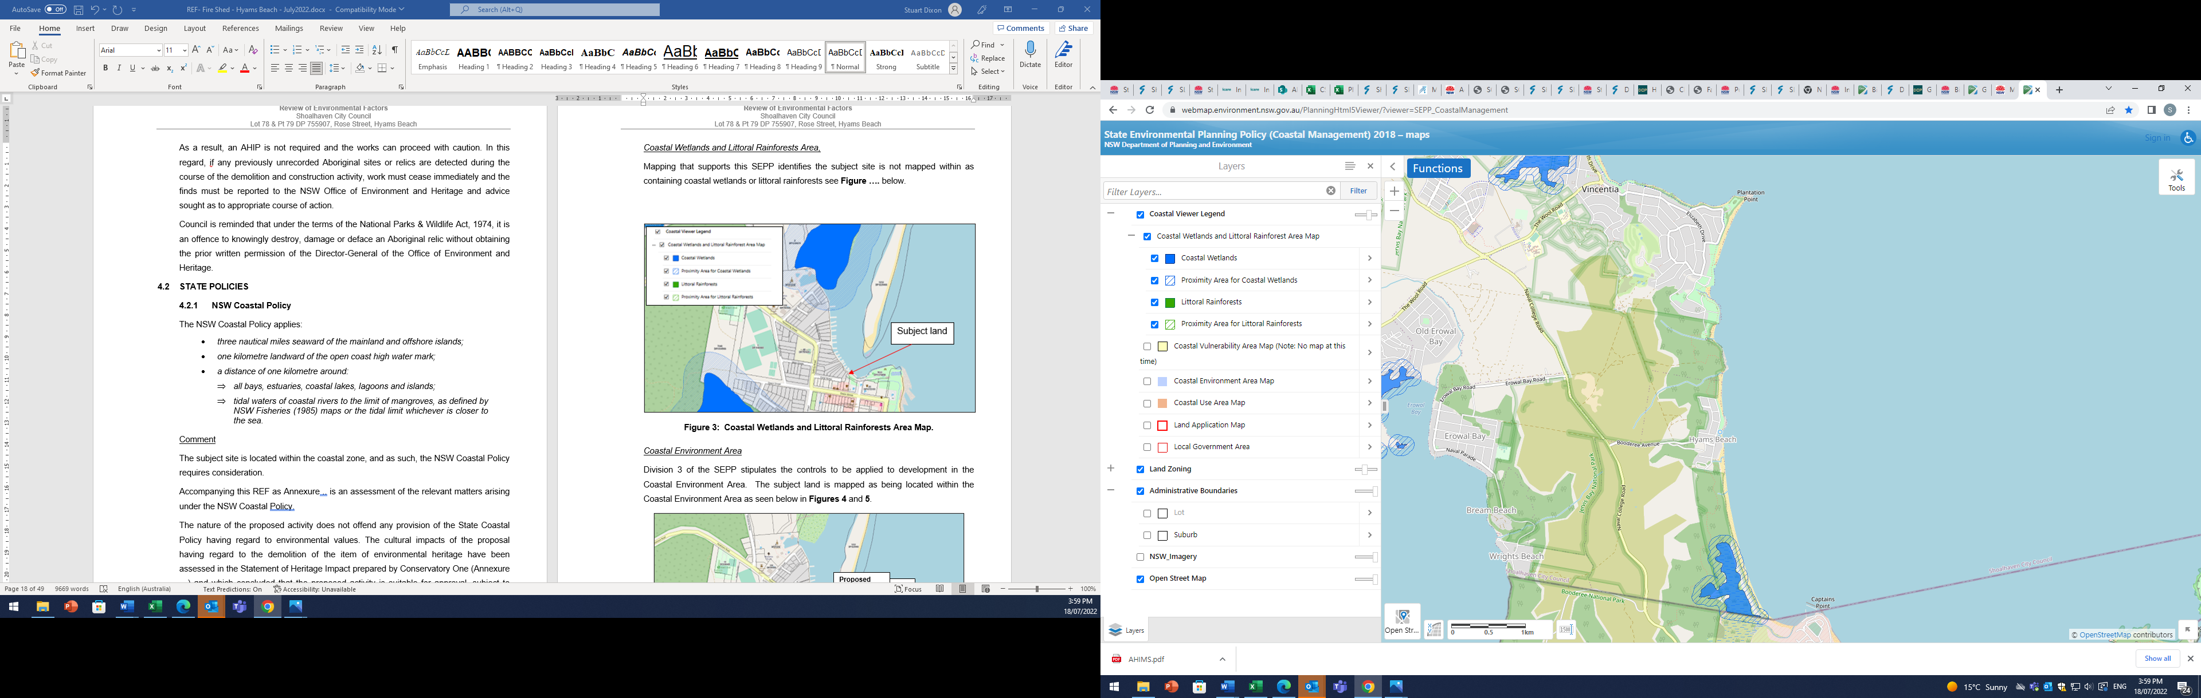
Site
Hyams Beach
Figure 4: Coastal Wetlands and Littoral Rainforests Area Map.
Coastal Environment Area
Division 3 of the SEPP stipulates the controls to be applied to development in the Coastal Environment Area. The subject land is not mapped as being located within the Coastal Environment Area as seen below in Figure 5.
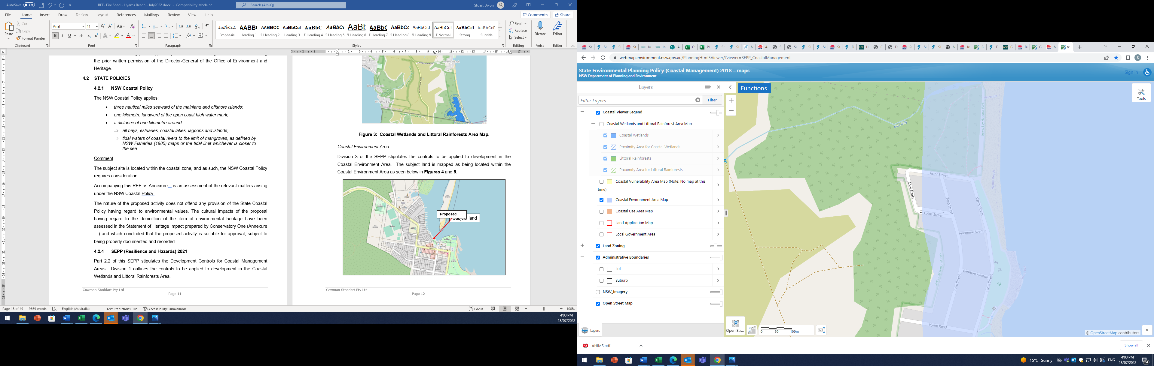
Site
Figure 5: Coastal Environment Area overlay.
Coastal Use Area
Division 4 of the SEPP specifies the controls to be applied to development in the Coastal Use Area.
The subject land is mapped under this SEPP as within the Coastal Use zone as seen below in Figure 6.

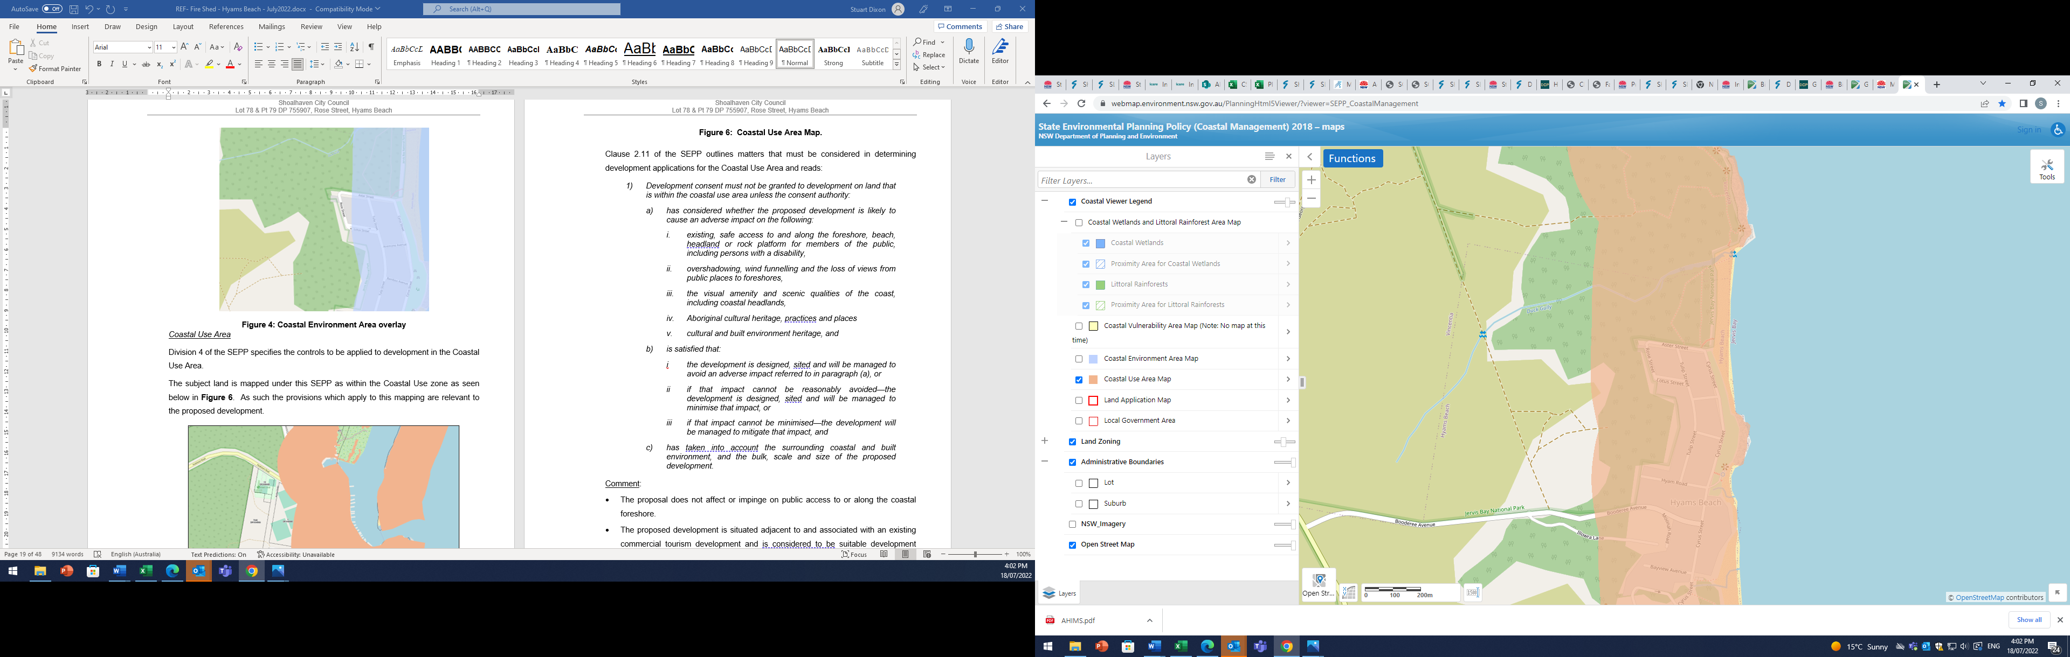
Site

Figure 6: Coastal Use Area Map.
Clause 2.11 of the SEPP outlines matters that must be considered in determining development applications for the Coastal Use Area and reads:
- Development consent must not be granted to development on land that is within the coastal use area unless the consent authority:
- has considered whether the proposed development is likely to cause an adverse impact on the following:
- existing, safe access to and along the foreshore, beach, headland or rock platform for members of the public, including persons with a disability,
- overshadowing, wind funnelling and the loss of views from public places to foreshores,
- the visual amenity and scenic qualities of the coast, including coastal headlands,
- Aboriginal cultural heritage, practices and places
- cultural and built environment heritage, and
b) is satisfied that:
i the development is designed, sited and will be managed to avoid an adverse impact referred to in paragraph (a), or
ii if that impact cannot be reasonably avoided—the development is designed, sited and will be managed to minimise that impact, or
iii if that impact cannot be minimised—the development will be managed to mitigate that impact, and
c) has taken into account the surrounding coastal and built environment, and the bulk, scale and size of the proposed development.
Comment:
- The activity does not affect or impinge on public access to or along the coastal foreshore.
- The activity does not result in overshadowing, wind funnelling or loss of views to foreshores.
- The activity does not result in adverse visual amenity or scenic impacts.
- The activity does not affect Aboriginal cultural heritage.
- The activity involves the demolition of an item of environmental heritage, however this has been considered in the Statement of Environmental Heritage prepared by CO and which has concluded that the demolition of the item is not unreasonable under the circumstances.
Coastal Vulnerability Area
The Department of Planning website does not contain any mapping of Coastal Vulnerability areas associated with the Resilience and Hazards SEPP. This mapping pertains to the impact of coastal hazards.
This development is not located within proximity of coastal hazard areas and will not increase the risk of coastal hazards.
Under these circumstances the proposal is considered to be consistent with the thrust and objectives of the Resilience and Hazards SEPP.
The proposal is considered to be consistent with the provisions of Chapter 2 were they to apply.

3.3.3.2 Chapter 4 – Remediation of Land
Chapter 4 of SEPP Resilience and Hazards deals with the remediation of land.
ENRS have undertaken a Waste Management Plan to address the collection, storage and disposal of waste. The WMP flows from an earlier assessment of ENRS in the form of a Hazardous Materials Survey Report.
ENRS in the WMP have identified the need for a Clearance Certificate for the ground surface at the site upon completion of the asbestos removal and building demolition works.
Furthermore, ENRS recommend that if contamination is encountered, or any soil or excavated is inadvertently removed or disposed of off-site, then it must be managed by a contaminated land consultant.
The proposed activity will result in the existing building being demolished, and all asbestos material being disposed of in accordance with relevant EPA requirements.
ENRS note the site history and use by the NSW RFS, and therefore a wide range of potential contaminants must be considered by the contractor.
The proposed activity is considerate of the remediation of land provisions.

3.3.4 State Environmental Planning Policy (Biodiversity and Conservation) 2021
The proposed activity will not result in the removal of any native vegetation and is not expected to result in any adverse impacts on biodiversity. Measures to avoid incidental impacts are recommended to protect vegetation on the site and avoid inadvertent weed introduction.

3.4 Shoalhaven Local Environmental Plan 2014 (SLEP)
Shoalhaven Local Environmental Plan 2014 (SLEP) applies to the subject land, which zones the site SP2 Infrastructure as shown in Figure 7.
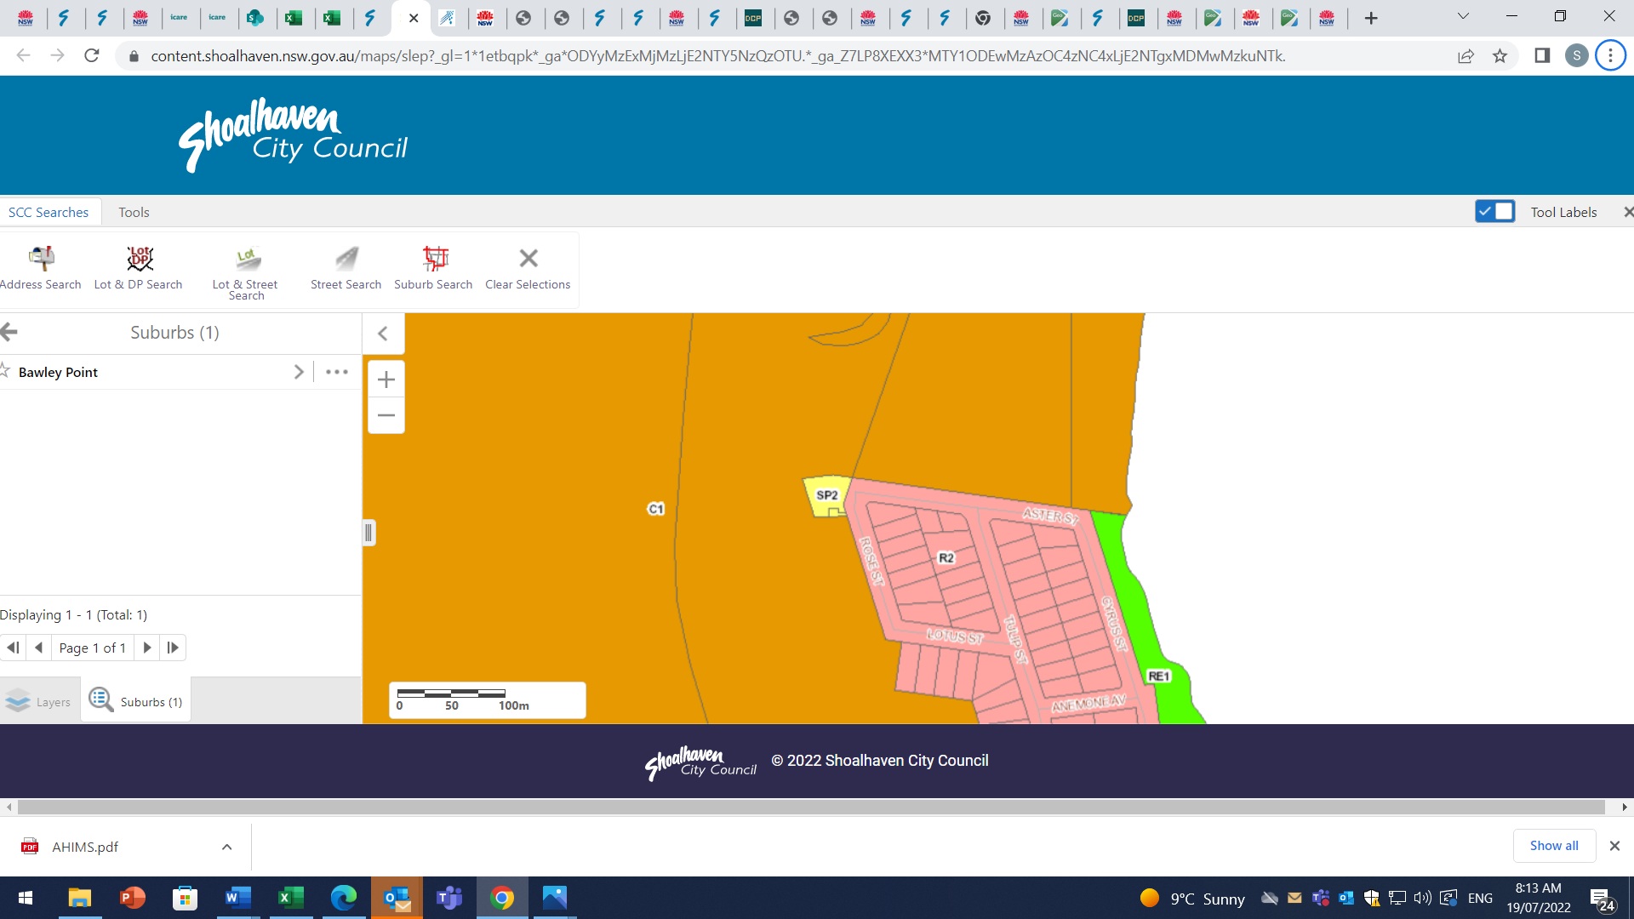
Site
Figure 7: Zoning Map (Shoalhaven LEP 2014)

The objectives of the SP2 zone are as follows:
- To provide for infrastructure and related uses.
- To prevent development that is not compatible with or that may detract from the provision of infrastructure.
The proposed activity is not incompatible with these objectives given the existing infrastructure is not fit for purpose and has been replaced elsewhere. Future use of the site can be considered by separate assessment in due course when alternative land uses have been identified.
As outlined above in Section 4.2.3, the proposal is permissible without consent under the provisions of SEPP (Transport and Infrastructure) 2021, and consequently, it is unnecessary to consider permissibility under SLEP.
Clause 5.12 of SLEP deals with Infrastructure Development and states that:
(1) This Plan does not restrict or prohibit, or enable the restriction or prohibition of, the carrying out of any development, by or on behalf of a public authority, that is permitted to be carried out with or without development consent, or that is exempt development, under State Environmental Planning Policy (Transport and Infrastructure) 2021, Chapter 2.
(2) This Plan does not restrict or prohibit, or enable the restriction or prohibition of, the use of existing buildings of the Crown by the Crown.
As outlined above in Section 4.2.3 of this REF, the proposed works are to be undertaken pursuant to the provisions of SEPP (Transport and Infrastructure). It is noted that pursuant to subclause (2), the provisions of SLEP must not restrict development permitted under SEPP Infrastructure.
Notwithstanding this, the following addresses the provisions and the site is mapped by the Shoalhaven LEP 2014 as follows:
- Containing an item of environmental heritage with local significance. The proposed activity involves the demolition of an item of environmental heritage. Accompanying this REF is a Statement of Heritage Impact prepared by CO which has assessed the significance of the building the subject of the works, and the impacts of the proposed works.
- Potential acid sulfate soils, however, the subject site is not located within 500 m of other potential ASS, and nor are the works expected to lower the water table. Consequently, no implications arise.
- Within the Jervis Bay area where Clause 7.20 of the LEP applies. The proposal, being for the demolition of a NSW RFS fire station does not offend any provisions of this clause. The proposal does not result in any adverse environmental impacts. Cultural impacts arising from the demolition of an identified heritage item are addressed below.
The activity is consistent with the provisions of the Shoalhaven LEP 2014 where they apply.

3.5 DRAFT PLANNING INSTRUMENTS
There are no Draft Planning Instruments that would affect the proposed works.

3.6 DEVELOPMENT CONTROL PLANS
The subject site is within that area affected by the provisions of the Shoalhaven DCP 2014. The Shoalhaven DCP 2014 contains a series of generic chapters that apply to the whole Shoalhaven and affect certain development, constraints and land uses, in addition to area specific chapters where Council has adopted specific controls.
The provisions of the Shoalhaven DCP 2014 only apply where development consent is required, and therefore have no implications for this project.
Having regard to the works assessed by this REF, the only relevant matters is Chapter G7 – Waste Minimisation and Management Controls. Accompanying this REF is a Waste Management Plan prepared by ENRS which has assessed the proposed works.

4.0 ENVIRONMENTAL CONSIDERATIONS

4.1 TOPOGRAPHY AND SOILS
The subject site is located on a slight gradient, sloping gently down to the east being the Rose Street frontage.
No identified drainage is apparent on the site, and surface water is expected to simulate the topography, flowing generally eastward towards Rose Street/Astor Street.
The site and adjoining lands are mapped by SLEP 2014 as containing acid sulfate soils comprising Class 5.

4.2 water and soil quality issues

4.2.1 Acid Sulfate Soils
Mapping accompanying the Shoalhaven LEP 2014 identifies lands which are potentially affected by acid sulfate soils (ASS). The subject site is affected by potential acid sulfate soils being mapped as Class 5.
The risk relates to excavation works within 500 metres of adjacent Class 1, 2, 3 or 4 land that is below 5 metres Australian Height Datum and by which the watertable is likely to be lowered below 1 metre Australian Height Datum on adjacent ASS land. Having regard to the potential acid sulfate soils identified on the subject site, these are not located within 500 m of other ASS lands. Furthermore, the minor nature of this activity is unlikely to lower the watertable on nearby lands.
Based on this, it is considered that no impacts arise on potential ASS.

4.2.2 Soil Erosion and Sedimentation Control
The proposal has the potential to adversely impact water quality due the mobilisation of sediment during the works where site disturbances will occur until the land is stabilised.
The subject site is not affected by significant constraints such as steeply sloping landform, unstable lands or containing water courses. Consequently, it is considered that typical sediment controls in the form of silt fences and hay bales will be appropriate for implementation. Furthermore, grass seeding to encourage vegetation growth to stabilise the site is also recommended.
The project is likely to result in minor short-term impacts and no long-lasting effects are expected.

4.2.3 Site Contamination
ENRS have undertaken a Waste Management Plan (WMP) to address the collection, storage and disposal of waste from the proposed activity. The WMP supplements an earlier assessment of ENRS in the form of a Hazardous Materials Survey Report.
The proposed activity will result in the existing building being demolished, and all asbestos material being disposed of in accordance with relevant EPA requirements.
ENRS in the WMP have identified the need for a Clearance Certificate for the ground surface at the site upon completion of the asbestos removal and building demolition works. Furthermore, ENRS recommend that if contamination is encountered, or any soil is inadvertently removed or disposed of off-site, then it must be managed by a contaminated land consultant.
ENRS note the site history and use by the NSW RFS, and therefore should consider a wide range of potential contaminants which must be reviewed by the contractor.
The proposed activity is considerate of the remediation of land provisions.

4.3 FLORA AND FAUNA
The proposed activity involves the demolition of an existing building being the NSW RFS fire station. The activity will not result in the removal of vegetation, nor otherwise impact the biodiversity values of the area.
Notwithstanding the above, the site does adjoin land that has habitat values, containing the Jervis Bay National Park. Care needs to be taken having regard to:
- mitigation of soil erosion during demolition works where site disturbances will arise,
- protection of vegetation during the demolition works to avoid unintended impacts;
- avoid the introduction and spread of weed species during demolition works,
- use of native grass species endemic to the area in any site stabilisation.
Provided work are undertaken to mitigate soil erosion, no impacts on fauna or flora are expected.

4.4 VISUAL IMPACT
The subject site contains the NSW RFS fire station, which is a modest single storey clad building. The building has limited aesthetic appeal, being of a very simple, functional design with no architectural merit. The building is largely screened from Rose Street by mature vegetation, and is not prominent in the landscape.
The activity involves the demolition of the structure in its entirety.
The demolition proposed is not expected to result in any adverse visual impacts given it involves the demolition of an existing building that does not positively contribute to the streetscape or scenic qualities of the locality. The building has no special scenic qualities that would warrant its retention. Furthermore, as will become evident in Section 4.5.2 below and the Statement of Heritage Impact prepared by CO to assess the proposed works, the building has no significant heritage value that warrants its retention.
The impacts will result in the complete removal of the building, with the material disposed of in accordance with the WMP prepared by ENRS.
It is expected that, following demolition of the building, the remaining vegetation on the site will result in the property blending with the immediately surrounding land.
Given this, no significant adverse impacts are anticipated from the works proposed to be undertaken.

4.5 Heritage

4.5.1 Indigenous Heritage
The proposed works involve the demolition of the former NSW RFS Fire station which is no longer fit for purpose.
As outlined above, no AHIP is required under the National Parks and Wildlife Act due to the site being already disturbed.
Furthermore, as outlined in the SOHI prepared by CO, an AHIMS search has not revealed the existence of any identified items in the vicinity of the property.
Consequently, it is unlikely that any material is existent on the site.
Notwithstanding the above, it is recommended that if any aboriginal material is unearthed during the proposed maintenance activities, work will be required to cease immediately and advice from National Parks & Wildlife Service will be sought before work continues.

4.5.2 Non-Indigenous Heritage
The subject site is identified by the Shoalhaven LEP 2104 as containing an item of environmental heritage with local significance, being the Hyams Beach bushfire station. The proposed activity involves the demolition of this item.
Accompanying this REF is a Statement of Heritage Impact prepared by CO which has assessed the impacts of the proposed activity. This is reproduced as Annexure 1.
The following is based on the SoHI of CO. CO have assessed the activity against the relevant guidelines including the Burra Charter Methodology and the NSW State Heritage Guidelines.
According to CO, the building only has heritage significance due to the manner in which the facility was funded and erected. In this regard, the building was funded through community fundraising activities, contributions by the Hyams Beach Progress Association, and constructed using volunteer labour. CO consider that, in applying the Burra Charter assessment of significance, the building meets category c) (social or spiritual value). CO consider that the building has no historical, aesthetic, or scientific significance. CO consider the grading of significance being D, being of “Little significance”.
In applying the NSW State Heritage Office criteria, the building satisfies criteria b) and d) (historical and social respectively), with the grading being D, which again is of “Little Value”.
According to the assessment against the relevant criteria of both the Burra Charter and the State Heritage Guidelines, CO consider that the building does not warrant local listing.
The SoHI of CO has examined possibilities for reuse or redevelopment of the site enabling the retention of the building, however notes the use of asbestos materials as a limiting factor for reuse, along with the relatively small size of the land, along with it being constrained by significant bush fire risks, with very limited ability for asset protection. These constraints prevent reuse opportunities.
Consequently, CO conclude that based on the limited significance of the item, its demolition will not unreasonably impact the social significance that is attributed to the item.
CO do however recommend the following mitigation measure:
If Council determines the demolition of the former Hyams Beach Rural Fire Station, it is strongly recommended to erect a permanent vandal-resistant structure as a memento to the former building in recognition of the 1960s community which took the initiative to erect the facility to help protect the community.
Based on the assessment of CO, it is evident that the building does not have sufficient heritage significance that would warrant its retention and the mitigation measures are supported by this REF.

4.6 TRAFFIC and transportation IMPACTS
Traffic impacts associated with the proposed works are expected to occur from traffic and parking associated with work crews undertaking the relevant demolition activity.
In time, traffic might be generated by a future use, dependent on the nature of the use ultimately decided for the property. This will need to be considered as part of any assessment that would be required for that future use.
The subject site has frontage to Rose Street near Aster Street which is the closest cross street. Both Rose Street and Aster Street are sealed public roads maintained by Shoalhaven Council. Neither Rose Street or Aster Street are anticipated to carry large volumes of traffic due to the relatively limited traffic emanating within Hyams Beach, which is a small coastal village with no through traffic.
Rose Street and Aster Street are relatively narrow, and no formal kerb and gutter is provided. Street parking is restricted to informal parking on the grass verge.
The site of the proposed works is currently accessible by vehicles and equipment and therefore access should not present any difficulty.
Having regard to the impacts associated with demolition traffic, these will only occur for a short period, expected to be approximately 4 weeks, and as such, are unlikely to lead to significant adverse traffic conflicts. Notwithstanding this, it is considered that a Traffic Management Plan should be prepared and implemented for the duration of the demolition works in order to ensure that demolition/contractor parking is properly managed to avoid impacting nearby properties.

4.7 amenity IMPACTS
The proposal has the potential to impact on the amenity of the locality during demolition works.
Construction impacts associated with the works would mainly relate to noise and dust. These impacts are somewhat mitigated by virtue of:
- the limited demolition phase being approximately 4 weeks;
- works being undertaken during normal daylight hours; and
- all plant and equipment operating at the site being used between 7:00 am and 5:00 pm during weekdays and 8:00 am to 1:00 pm on weekends as background noise levels are normally higher than other times during the day. No work is to be undertaken on Sundays.
These measures will ensure that impacts are suitably ameliorated and are therefore recommended in this REF.

4.8 SERVICING
The locality is well serviced with all essential infrastructure in the form of:
- Electricity;
- Telecommunications;
- Reticulated water and sewerage services; and
- Limited street drainage.
All relevant services for the activity are available, and do not require extension.

4.9 WASTE MANAGEMENT
The proposal will result in the generation of waste in the demolition of the building.
ENRS has prepared a WMP to assess the generation of waste and this comprises Annexure 2 attached to this REF.
The WMP of ENRS aims to:
- Ensure waste and hazardous materials are removed and disposed of in a safe manner;
- Minimise the generation of waste to landfill;
- Maximise waste material avoidance and reuse on Site;
- Ensure that where practicable, an efficient recycling procedure is applied to waste materials; and
- Raise awareness among employees and subcontractors of their waste management responsibilities.
ENRS previously undertook a Hazardous Materials Survey Report (HAZMAT) which identified the extent of hazardous materials existent in the building. These included:
- Non-friable asbestos containing materials;
- Friable asbestos in building dust;
- Light fittings containing Poly Chlorinated Biphenyls (PCB);
- Synthetic mineral fibres (SMF) in linoleum; and
- Hazardous chemicals associated with commercial cleaning and mechanical fluids.
The WMP prepared by ENRS has identified the building as containing a range of materials including:
- Asbestos;
- Bricks;
- Steel;
- Timber;
- Gyprock;
- Tiles;
- Concrete;
- Carpet; and
- General waste.
The WMP of ENRS has recommended that waste generation be minimised by:
- separating and sorting to maximise material for recycling, and minimise that destined for disposal;
- reusing material where possible;
- recycling materials that is able to be recycled; and
- properly disposing of materials, particularly hazardous materials, at a licensed waste facility.
ENRS have identified waste sources and management measures that should be implemented:
- litter management which shall be controlled by daily inspections, provision of adequate waste and recycling storage containers, and the training of staff on litter management;
- green waste is not anticipated but can be reused on site if needed.
Compliance with the provisions of the WMP prepared by ENRS is recommended.

4.10 natural hazards

4.10.1 Bushfire
The subject site is identified by mapping prepared by Shoalhaven Council and endorsed by the NSW Rural Fire Service as being bushfire prone (see Figure 8).
However, the nature of the proposed activity is not adversely affected by the risk of bushfire. Furthermore, the proposed demolition of this structure will assist with mitigation in the event that a bushfire occurs.
Given the above, no mitigation measures are recommended having regard to bushfire.
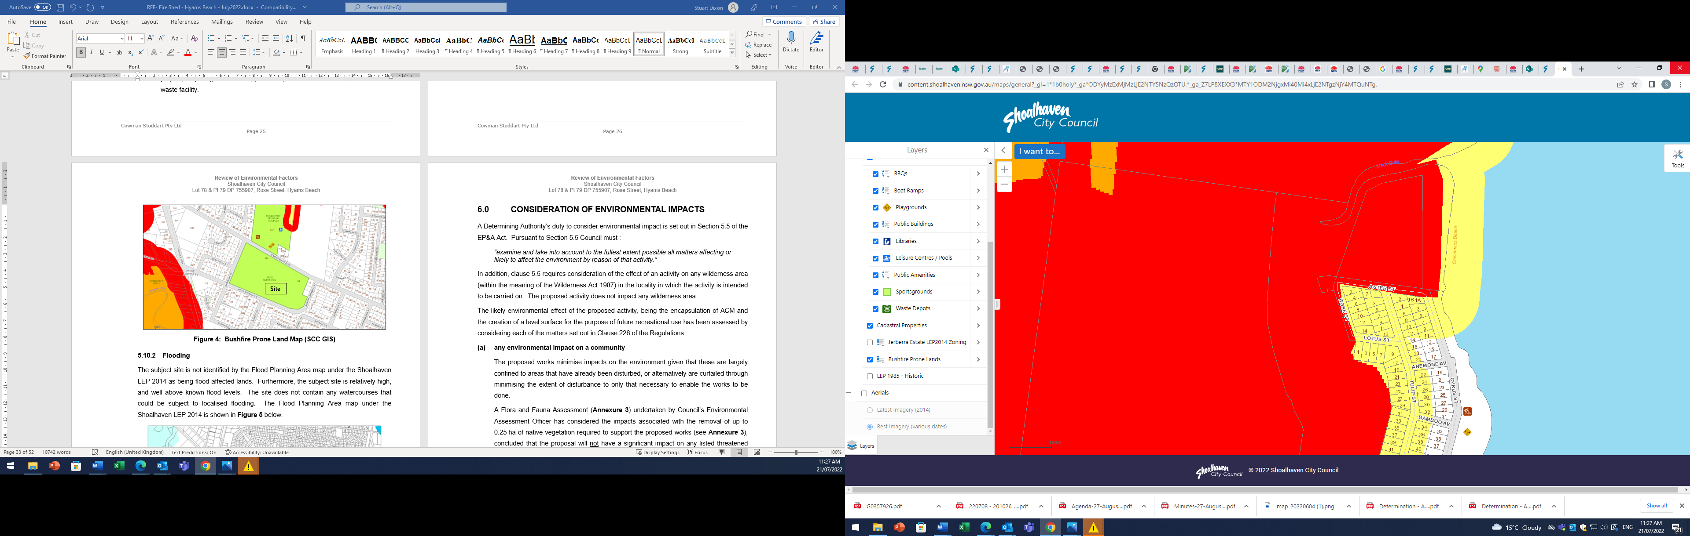
Site
Figure 8: Bushfire Prone Land Map (SCC GIS)

4.10.2 Flooding
The subject site is not identified by the Flood Planning Area map under the Shoalhaven LEP 2014 as being flood affected lands. Furthermore, the subject site is relatively high, and well above known flood levels. The site does not contain any watercourses that could be subject to localised flooding.
Given the above, no mitigation measures are recommended having regard to flooding.

5.0 CONSIDERATION OF ENVIRONMENTAL IMPACTS
A Determining Authority’s duty to consider environmental impact is set out in Section 5.5 of the EP&A Act. Pursuant to Section 5.5 Council must :
“examine and take into account to the fullest extent possible all matters affecting or likely to affect the environment by reason of that activity.”
In addition, clause 5.5 requires consideration of the effect of an activity on any wilderness area (within the meaning of the Wilderness Act 1987) in the locality in which the activity is intended to be carried on. The proposed activity does not impact any wilderness area.
The likely environmental effect of the proposed activity, being the demolition of an existing NSW Rural Fire Services Fire Station has been assessed by considering each of the matters set out in Clause 228 of the Regulations.
(a) any environmental impact on a community
The proposed activity is relatively minor and is not expected to result in unreasonable environmental impacts on the community. Notwithstanding this, it is recommended that measures be implemented to protect the community through the preparation, implementation and compliance with the following:
- Traffic Management Plan for implementation during the demolition works;
- Sedimentation control plan for implementation until the site is stabilised;
- Structure to recognise former building and the community initiative to facility its construction;
- Hours of operation;
- Demolition Management Plan; and
- Waste Management Plan.
(b) any transformation of a locality
It is not expected that the locality will be unreasonably transformed as a result of the activity. In this regard, the activity involves the demolition of a building which is not prominent in the landscape and which has no aesthetic quality.
Future use of the property will be separately determined and assessment/application will be required for any subsequent development proposed.
Mitigation in the form of permanent recognition of the community who facilitated the construction of the building is recommended.

(c) any environmental impact on the ecosystem of the locality
The proposed works are not expected to have any significant impact on ecosystems given the condition of the subject site and the works proposed. It is not proposed to remove any vegetation to accommodate the demolition works proposed.
Notwithstanding this, measures are recommended to further mitigate the impacts of the activity in the form of:
- sedimentation controls during demolition works where site disturbances will arise;
- protection of vegetation during the demolition works to avoid unintended impacts;
- avoiding the introduction and spread of weed species during demolition works;
- use of native grass species endemic to the area in site stabilisation works.
(d) any reduction of the aesthetic, recreational, scientific or other environmental quality or value of a locality
The activity does not result in the unreasonable reduction in the aesthetic, recreational, scientific or other environmental quality or value of the locality due to the nature of the building being demolished and the character of the site.
(e) any effect on a locality, place or building having aesthetic, anthropological, archaeological, architectural, cultural, historical, scientific or social significance or other special value for present or future generations
The site is identified as containing an item of environmental heritage by the Shoalhaven LEP. The proposed activity has been assessed by CO in a SoHI which has concluded that the building has little significance, limited to the social significance due to the manner in which it was funded and erected. CO do not consider the significance will be diminished by the demolition of the building, however recommended that mitigation in the form of a permanent structure as recognition of that community.
Having regard to indigenous cultural heritage matters, the works are proposed on land which has been substantially disturbed by past development practices.
(f) any impact on the habitat of protected fauna (within the meaning of the Biodiversity Conservation Act 2016)
The proposed works do not impact on the habitat of protected fauna as the proposal is for the demolition of an existing building only, on land that is already disturbed by past development activities.
Mitigation measures are recommended to minimise overall impacts in the terms of:
- sedimentation controls during demolition works where site disturbances will arise;
- protection of vegetation during the demolition works to avoid unintended impacts;
- avoiding the introduction and spread of weed species during demolition works;
- use of native grass species endemic to the area in site stabilisation works.
(g) any endangering of any species of animal, plant or other form of life, whether living on land, or water or in the air
The proposal will not endanger any plant or animal species as it for the demolition of an existing building only, on land that is already disturbed by past development activities.
(h) any long-term effects on the environment
The proposed works are not expected to result in any long-term effects due to the short period of demolition, and the resultant nature of the site following completion of the works.
Works are recommended to encourage the stabilisation of the site to mitigate further erosion and to control sediment.
Any future use of the site will require separate assessment.
(i) any degradation of the quality of the environment
It is considered that there will be no degradation to the quality of the environment given the minor nature of the works. Mitigation is proposed in the form of:
- sedimentation controls during demolition works where site disturbances will arise;
- protection of vegetation during the demolition works to avoid unintended impacts;
- avoiding the introduction and spread of weed species during demolition works;
- use of native grass species endemic to the area in site stabilisation works.
(j) any risk to safety of the environment
The proposal does not cause a risk to the environment subject to compliance with the remediation works that are recommended by ENRS (Annexure 2) and which include appropriate disposal of asbestos waste.
(k) any reduction in the range of beneficial uses of the environment
The proposed works will not unreasonably affect the range of beneficial uses of the environment. The building as it currently stands is not fit for purpose, whist the site itself is heavily constrained due to the small size of the property, coupled with it being bush fire prone, with compliance with Planning for Bushfire Protection being difficult to achieve. Any future use of the site will require consideration and assessment.

(l) any pollution of the environment
The proposed activity has the potential to pollute the environment during the demolition phase, and until the site is stabilised.
The recommendations of this REF include the following mitigation measures which when implemented will avoid impacts:
- sedimentation controls for implementation during the demolition phase, and until the land is stabilised;
- disposal of all material, including asbestos, in accordance with the WMP prepared by ENRS (Annexure 2).
On this basis, the proposal is unlikely to result in the pollution of the environment.
(m) any environmental problems associated with the disposal of waste
Waste disposal, including asbestos waste, is to be carried out in accordance with the WMP prepared by ENRS (Annexure 2), and disposed of at suitably licensed facilities.
(n) any increased demands on resources (natural or otherwise) that are, or are likely to become, in short supply
The activity involves demolition of the existing building only. The activity will not increase demand for resources that are currently in short supply or likely to become in short supply.
(o) any cumulative environmental effect with other existing or likely future activities.
The proposal is specific to the subject site, and as such, is unlikely to result in any cumulative impacts.
(p) any impact on coastal processes and coastal hazards, including those under projected climate change conditions.
The location of the proposed works is such that no impacts arise on coastal processes or hazards.

6.0 RECOMMENDATIONS FOR environmental
management

6.1 Licences and Approval Requirements
All activities carried out in the project area as part of the demolition and construction must comply with relevant environmental legislation and regulations. Section 4.0 of this REF details the overall legislation framework which relates to a project of this nature. Other approvals that may be required under State legislation are provided in Table 1 below. As indicated some of the approvals listed are not, at this stage, required but depending on the nature of the demolition activities may be required as work proceeds.
Table 1
Approvals under NSW Legislation
Act | Authority | Requirements
Protection of the Environment Operations Act, 1997 | Environment Protection Authority | Council would need to ensure that waste is disposed to an EPA approved waste depot. Licences are also required for the generating or storing certain hazardous wastes.
Contaminated Land Management Act, 1997 | Environment Protection Authority | Notify EPA of certain contamination. This does not apply in this instance due to the low level concentrations, however Council may elect to notify the NSW EPA regardless.
Heritage Act, 1977 | Office of Environment and Heritage | If any heritage sites are disturbed an excavation permit for disturbing sites known or suspected to contain relics would be required.
National Parks and Wildlife Act, 1974  Section 90 | Office of Environment and Heritage | If there is destruction or disturbance of an Aboriginal relic or place, approval would be required under s.90.

6.2 recommendations for Environmental Management
The recommendations of this REF seek to ensure that Council will undertake the construction activities so that potential environmental impacts are avoided or minimised.
Council (and any contractors) should manage environmental impacts by careful planning and implementation of best management environmental mitigation practices during construction activities.
To fulfil these obligations, Council (and any contractors) should comply with the following recommendations in undertaking the work:

Heritage
- Council must record the asset prior to commencing demolition, in accordance with Heritage Office guidelines (see How to Prepare Archives Records of Heritage Items and Guidelines for Photographic Recording of Heritage Sites, Buildings and Structures) and should lodge the record with the State Library and the local council library.
- In accordance with the recommendations contained in the SoHI prepared by Conservatory One, Council must erect a permanent vandal-resistant structure near the frontage of the site to Rose Street as a memento to the former building in recognition of the 1960s community which took the initiative to erect the facility to help protect the community.
- All personnel are to be informed of their legal obligations if any Indigenous heritage material is uncovered during demolition and construction works.
- Council must seek an Aboriginal Heritage Impact Permit if required to remove or harm any objects uncovered by the works.
- Council must seek approval from the Office of Environment and Heritage for consent to destroy any artefact so found if necessary and undertake consultation with the relevant Local Aboriginal Land Council as deemed necessary by OEH.
Waste management
- Waste management must be undertaken in accordance with the Waste Management Plan prepared by ENRS in regard to all matters, however particularly having regard to:
  - Hazardous waste materials;
  - Soil contamination and obtaining a Site Clearance Certificate;
  - Training;
  - Waste recording; and
  - Overall waste management principles.
Traffic
- A Traffic Management Plan is to be prepared in order to ensure that traffic and contractor parking is properly managed to avoid impacts on the public road network.
- All temporary vehicle parking during the construction phase is to be undertaken on existing disturbed areas and no vegetation clearance or disturbance is permitted.

Site Management
- A Demolition Management Plan should be prepared by the contractor and include:
  - site compound;
  - vehicular access to the site;
  - vehicle and plant parking, which is to be undertaken on disturbed areas;
  - material storage area;
  - compliance with the Waste Management Plan;
  - Soil Erosion and Sedimentation Control Plan which must consider:
- Stabilized site entry where required;
- The installation of geotextile fabric downslope of disturbed areas;
- Provision of staked hay bales being provided where concentrated flows are likely to occur, and are to remain until such time as disturbed areas are stabilised; and
- All disturbed areas are to be stabilised as soon as possible following completion of the works with native grass species that are endemic to the locality.
  - Compliance with the Traffic Management Plan;
  - Compliance with the Waste Management Plan.
Environment and Vegetation Protection
- Works are to be undertaken in a manner to avoid the unnecessary disturbance of vegetation, and avoid the removal of any tree.
- Trees in the vicinity of demolition works are to be suitably protected prior to any demolition works commencing.
- Vehicles and machinery entering the site must be reasonably clean and free of dirt or mud from other sites.
Water Quality
- Council must require that all measures recommended by the Soil Erosion and Sedimentation Control Plan are installed prior to demolition works commencing and must be maintained for the duration of works until disturbed areas are stabilised and grass is established.

Air Quality General Requirements
- All site vehicles and machinery should be fitted with appropriate emission control equipment, maintained frequently and serviced to manufacturer’s specifications.
Noise Quality
- All construction work is to be programmed to ensure minimal disturbance to the local community.
- Noisy plant and equipment is to be used between 7:00 am and 5:00 pm during weekdays and 8:00 am to 1:00 pm on Saturdays as background noise levels are normally higher than other times during the day. No work is to be undertaken on Sundays.
- Loud equipment should where possible have a noise directional characteristic so that noise is minimised in sensitive areas.
- Keep engine covers closed.
- Ensure that noisy machinery is not left running when not required.
- All construction equipment is to be well maintained.
Maintenance of Machinery and Equipment (Storage, Maintenance and Refuelling)
- Where practicable maintenance and repairs of machinery and equipment is to be undertaken off-site. Storage of plant and equipment shall be limited to the area identified in the Demolition Management Plan.
Consultation
- Council shall consider consultation with the community and provide an opportunity to comment on the proposed demolition works.
- Council shall consult with the Jerrinja Local Aboriginal Land Council and provide an opportunity to provide comment on the proposal to demolish the building.

7.0 CONSULTATION
To insert following public exhibition of REF and related material.

8.0 CONCLUSION and RECOMMENDATIONS
The purpose of this report is to address the environmental impacts specifically associated with:
- the demolition of the Hyams Beach NSW Rural Fire Services fire station. This REF has been prepared in accordance with the requirements of Part 5 and Clause 228 of the Environment Planning & Assessment Act and Regulations respectively.
The report has found that:
- The proposal is not inconsistent with any state legislation or policies, regional or local planning provisions.
- The building has very limited heritage significance which does not warrant its retention, however, does require recognition of the community that was instrumental in its erection in accordance with the recommendation of Conservatory One contained in the SoHI (Annexure 1).
- The proposal will not adversely impact any threatened flora and fauna or their habitats, however measures are required to protect against inadvertent vegetation removal.
- The proposal will not unreasonably impact on the visual amenity of the locality.
- A Traffic Management Plan is required to ensure that no unreasonable impacts on traffic or parking arise.
- The proposal will not unreasonably impact on the amenity of the locality and measures to protect the amenity are recommended.
- Compliance is required with the Waste Management Plan prepared by ENRS (Annexure 2).
- A Demolition Management Plan should be prepared by the contractor undertaking the demolition works.
- If during demolition or construction works any aboriginal relics are uncovered, all works are to cease and advice will be sought from the NSW Office of Environment and Heritage before work continues.
- Council must undertake consultation with the community.

9.0 DETERMINATION
This Review of Environmental Factors assesses the likely impact of a proposal by Shoalhaven City Council for:
- the demolition of the Hyams Beach NSW Rural Fire Services fire station. This REF has been prepared in accordance with the requirements of Part 5 and Clause 228 of the Environment Planning & Assessment Act and Regulations respectively.
Shoalhaven City Council has:
(i) engaged Cowman Stoddart Pty Ltd, Town Planning, Agricultural and Environmental Consultants, to prepare a Review of Environmental Factors which describes the proposed works and assesses likely environmental impacts in accordance with Part 5 of the Environmental Planning and Assessment Act 1979;
(ii) considered the potential environmental effects of the proposal and the effectiveness and feasibility of means of reducing or preventing detrimental effects.

I, …………………….. as Director, City Services, of Shoalhaven City Council hereby determine that the proposed works will proceed.
(i) I have determined that it is unlikely that there will be any significant environmental impact as a result of the proposed works;
(ii) the proposed safeguards identified in the REF are to be adopted;
(iii) no environmental impact statement is required for the proposed works; and
(iv) the proposed activity is not likely to significantly affect threatened species, populations or ecological communities or their habitats and a Species Impact Statement is not required.

................................................................ ........................................................2022
Director - City Services Date
………………………………………………….
Shoalhaven City Council
Prepared by:

Stuart Dixon RPIA ………………………………………. 2022
Cowman Stoddart Pty Ltd Date

ANNEXURE 1

Statement of Heritage Impact

prepared by
Conservatory One

Lot 78 and Pt Lot 79 DP 755907
Rose Street, Hyams Beach

COWMAN STODDART PTY LTD
ANNEXURE 2

Waste Management Plan

prepared by
Environment and Natural Resources Solutions

Lot 78 and Pt Lot 79 DP 755907
Rose Street, Hyams Beach

COWMAN STODDART PTY LTD
ANNEXURE 3

NSW Coastal Policy 1997
Compliance Checklist

prepared by
Cowman Stoddart Pty Ltd

Lot 78 and Pt Lot 79 DP 755907
Rose Street, Hyams Beach

COWMAN STODDART PTY LTD

